Guide To Delegating PO Approval Authority in the Oracle ERP System

General Rules / notes on Approvals.

The approval of Purchase Orders is controlled by “Approval Routes” in Oracle ERP System. An example of an Approval Route is shown below. These Approval Routes are created and maintained by Finance. Any requests for any permanent changes to an approval route must be made to the local Finance department.

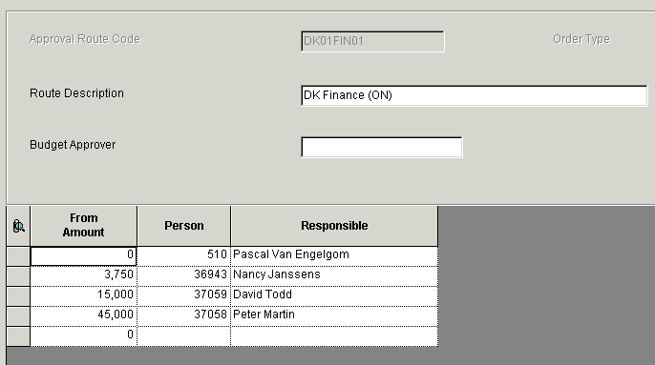

However it is possible to temporary delegate the approval of PO’s for a cost centre.
This delegation can be carried out by the cost centre / budget owner. Guidelines on who can be a delegated approver should be sought from local Finance.

Temporary delegated approvals are not time bound by the system. So the delegated approver will have to delegate back to you upon your return.

Steps on how to delegate approval authority.

1. After logging into the Oracle ERP System, expand your user menu until you see the “Approval Delegation” option
as shown below.

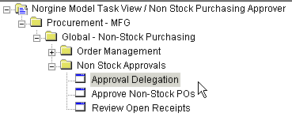

2. Double click on the “Approval Delegation” option.

3. In the “Work With Approval Delegation screen, input your user number and then click the
“Find” Button.

– if you do not know your number this can be found by clicking on the search icon
(circled) in the Approver field, inputting your first name and clicking find – then double
clicking on the line with your name.



4. After clicking the “Find” button, your cost centre(s) will be displayed.

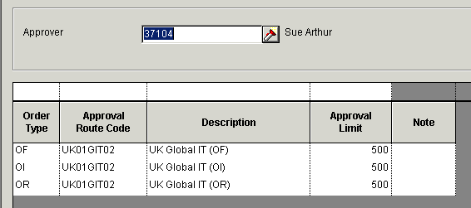

5. Double click on the cost centre for which you wish to temporarily delegate approval authority.

6. Input the number of the user to whom you delegating approval authority. This can be found
following the same instructions as in step 3.

7. After the delegated to user id has been input, click the “OK” button. Then click the “Close”
button to return to your menu.

